Day 20 - 12th Aug 2026
Task 1:
What do you understand about integration testing?
Integration testing is a type of software testing where we test two or more modules/components together to make sure they work correctly when they interact with each other.
The main focus is on communication and data flow between components, rather than testing each component individually.

Task 2:
Where do you use it and when ?
Integration testing is used when multiple modules, services, or components need to work together and we want to verify that their interaction is correct.
Area | Example
Frontend + Backend | Angular/React application calling a Java REST API
Backend + Database | Java service saving and retrieving data from MySQL
API + External Service | Payment service communicating with a payment gateway
Multiple Services | Microservice A communicating with Microservice B
Authentication | Login component → Auth service → Database
Message systems | Application → Kafka/RabbitMQ → Consumer

Login request
↓
Angular
↓
REST API
↓
Authentication Service
↓
MySQL
↓
User information returned

If the API is working individually and the database is working individually, but the API cannot correctly retrieve the user from the database, integration testing should detect that problem.

Task 3:
Can you write an integration test for your existing code ?
9.46 to 9.50

For example 🎉
java
@SpringBootTest
@AutoConfigureMockMvc
class UserControllerIT {

@Autowired
private MockMvc mockMvc;

@Test
void testGetUser() throws Exception {
mockMvc.perform(get("/users/1"))
.andExpect(status().isOk())
.andExpect(jsonPath("$.name").value("Alice"));
}
}

package com.bank;
import org.junit.jupiter.api.Test;
import org.springframework.beans.factory.annotation.Autowired;
import org.springframework.boot.test.autoconfigure.web.servlet.AutoConfigureMockMvc;
import org.springframework.boot.test.context.SpringBootTest;
import org.springframework.test.web.servlet.MockMvc;
import static org.springframework.test.web.servlet.request.MockMvcRequestBuilders.get;
import static org.springframework.test.web.servlet.result.MockMvcResultMatchers.jsonPath;
import static org.springframework.test.web.servlet.result.MockMvcResultMatchers.status;
@SpringBootTest
@AutoConfigureMockMvc
class UserControllerIT {
@Autowired
private MockMvc mockMvc;
@Test
void testGetUser() throws Exception {
mockMvc.perform(get("/users/1"))
.andExpect(status().isOk())
.andExpect(jsonPath("$.name").value("Alice"));
}
}

Task 4:
What are test containers?
Testcontainers is a Java library that allows us to run real external dependencies inside Docker containers during tests.
For example, suppose our Spring Boot application uses MySQL.
Instead of connecting our test to a MySQL database installed on our computer, Testcontainers can automatically start a temporary MySQL Docker container for the test.
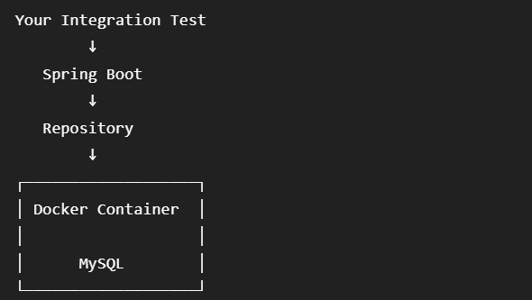

Testcontainers gives us a real MySQL instance without requiring you to permanently install/configure MySQL for your tests.
@Testcontainers
@SpringBootTest
class UserRepositoryIT {

@Container
static MySQLContainer<?> mysql =
new MySQLContainer<>("mysql:8.0");

@Test
void testUserRepository() {
// test repository with real MySQL
}
}

You can use containers for things such as:
MySQL
PostgreSQL
MongoDB
Redis
Kafka
RabbitMQ
Elasticsearch

Task 5:
When do we use ? and what is the need for test containers?
We use Testcontainers when our integration test needs a real external dependency, such as a database, Kafka, Redis, RabbitMQ, etc.

Task 6:
Can you write a piece of code for your existing application to see how test container works?
10.16 to 10.20

Code sample:

java
@Testcontainers
class UserRepositoryIT {

@Container
static PostgreSQLContainer<?> postgres = new PostgreSQLContainer<>("postgres:15");

@Autowired
private UserRepository userRepository;

@Test
void testSaveUser() {
User user = new User("Alice");
userRepository.save(user);
assertEquals("Alice", userRepository.findById(user.getId()).get().getName());
}
}

package com.bank;
import org.junit.jupiter.api.Test;
import org.springframework.beans.factory.annotation.Autowired;
import org.springframework.boot.test.context.SpringBootTest;
import org.springframework.boot.testcontainers.service.connection.ServiceConnection;
import org.testcontainers.containers.PostgreSQLContainer;
import org.testcontainers.junit.jupiter.Container;
import org.testcontainers.junit.jupiter.Testcontainers;
import static org.junit.jupiter.api.Assertions.assertEquals;
import static org.junit.jupiter.api.Assertions.assertNotNull;
@Testcontainers
@SpringBootTest
class UserRepositoryIT {
@Container
@ServiceConnection
static PostgreSQLContainer<?> postgres =
new PostgreSQLContainer<>("postgres:15");
@Autowired
private UserRepository userRepository;
@Test
void testSaveUser() {
// Create user
User user = new User("Alice");
// Save to PostgreSQL
User savedUser = userRepository.save(user);
// ID should be generated by PostgreSQL
assertNotNull(savedUser.getId());
// Fetch from PostgreSQL
User foundUser = userRepository
.findById(savedUser.getId())
.orElseThrow();
// Verify
assertEquals("Alice", foundUser.getName());
}
}

Task 7:
What is code coverage ?
Code coverage is a metric that tells us how much of our source code is executed when we run our tests
Type | What it measures
Line Coverage | How many lines of code were executed
Statement Coverage | How many statements were executed
Branch Coverage | How many if/else or decision branches were tested
Method Coverage | How many methods were called during testing

Task 8:
What’s the need for code coverage?
The main need for code coverage is to determine which parts of our application are actually tested and which parts are not.
Why do we need Code Coverage?
- Find untested code
Helps identify lines, methods, or branches that our tests never execute.
- Improve test quality
Shows where additional test cases may be required.
- Detect gaps in testing
For example, if an if/else has only one branch tested, coverage can reveal the missing branch.
- Increase confidence
Higher meaningful coverage gives developers more confidence that important parts of the application have been tested.
- Maintain quality during development
Teams can monitor coverage when new code is added and make sure testing doesn't fall behind.

Task 9:

Plz ensure your project is similar to the above structure .. need not have to be exactly same.

Now 1. We will reach out to the Web (Http / Ajax)

lets simulate a backend API call using fetch. In accountDetails.java class in useEffect..

we will use fetch
// we are Simulate backend API call (replace with real endpoint)
fetch("https://api.examplebank.com/accounts/12345")

import React, { useEffect, useState } from "react";

function AccountDetails() {

const [account, setAccount] = useState(null);
const [loading, setLoading] = useState(true);
const [error, setError] = useState(null);

useEffect(() => {

// Simulate backend API call
fetch("https://api.examplebank.com/accounts/12345")
.then((response) => {
if (!response.ok) {
throw new Error("Failed to fetch account details");
}

return response.json();
})
.then((data) => {
setAccount(data);
setLoading(false);
})
.catch((error) => {
setError(error.message);
setLoading(false);
});

}, []);

if (loading) {
return <p>Loading account details...</p>;
}

if (error) {
return <p>Error: {error}</p>;
}

return (
<div>
<h2>Account Details</h2>

{account && (
<>
<p>Account Number: {account.accountNumber}</p>
<p>Account Holder: {account.accountHolder}</p>
<p>Balance: ₹{account.balance}</p>
</>
)}
</div>
);
}

export default AccountDetails;

Routing
import { BrowserRouter, Routes, Route } from "react-router-dom";
import Dashboard from "./Pages/DashBoard/DashBoard";
import Account from "./Pages/Account/Account";
import TransactionProvider from "./contexts/TransactionContext";

export default function App() {
return (
<TransactionProvider>
<BrowserRouter>
<Routes>
<Route path="/" element={<Dashboard />} />
<Route path="/account" element={<Account />} />
</Routes>
</BrowserRouter>
</TransactionProvider>
);
}

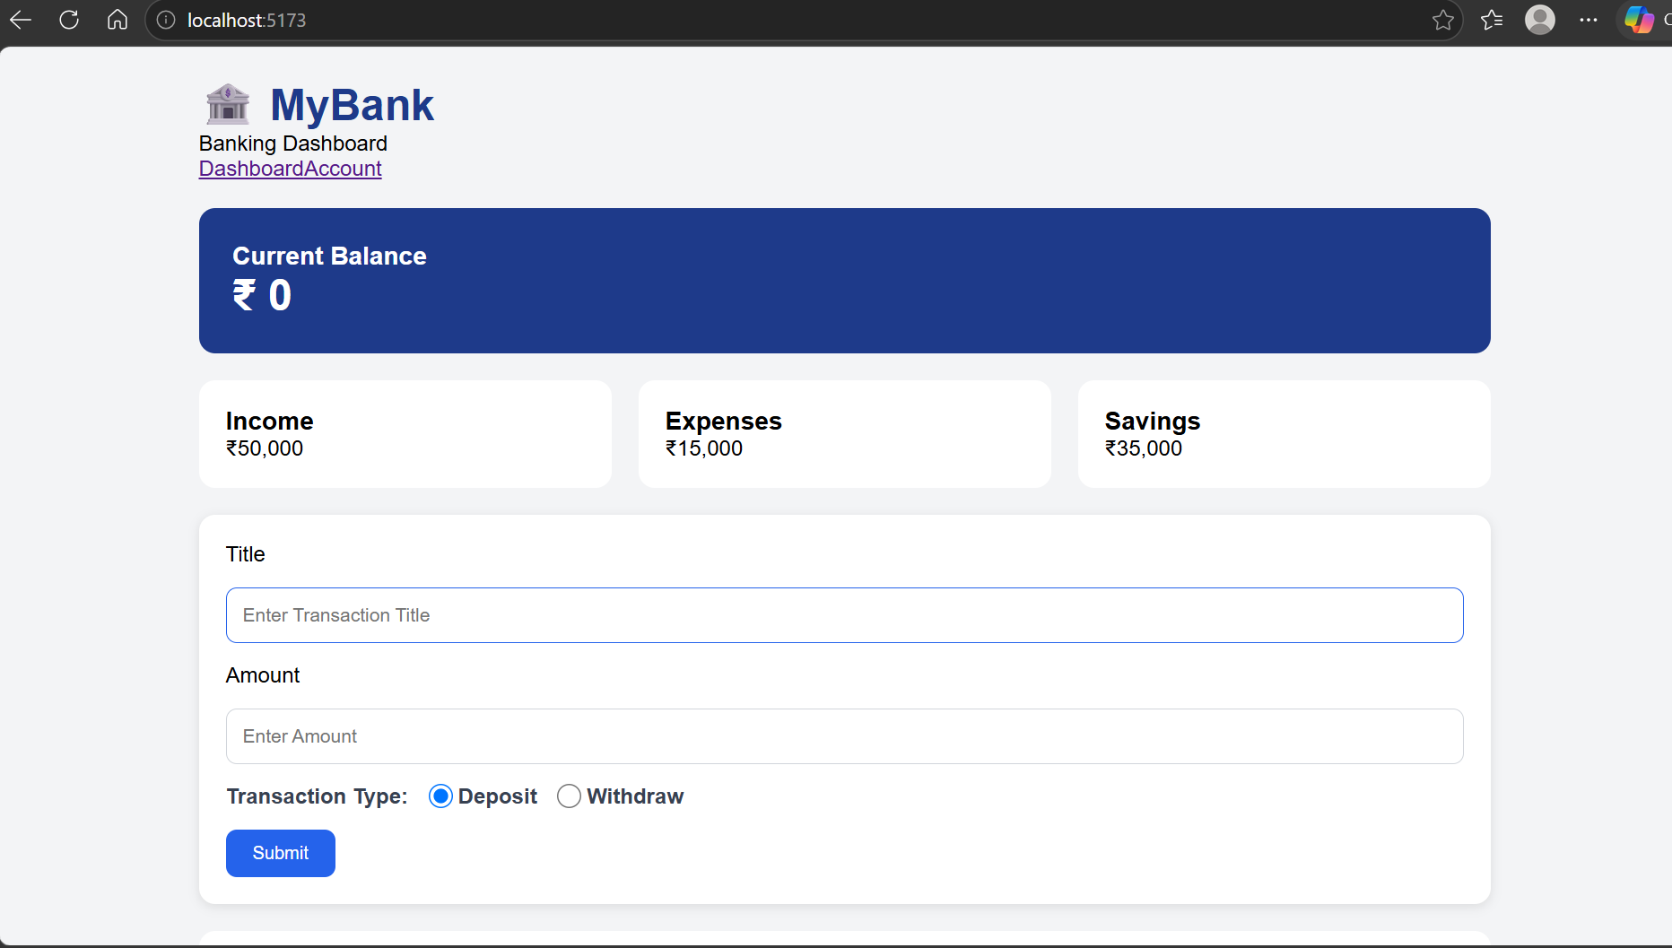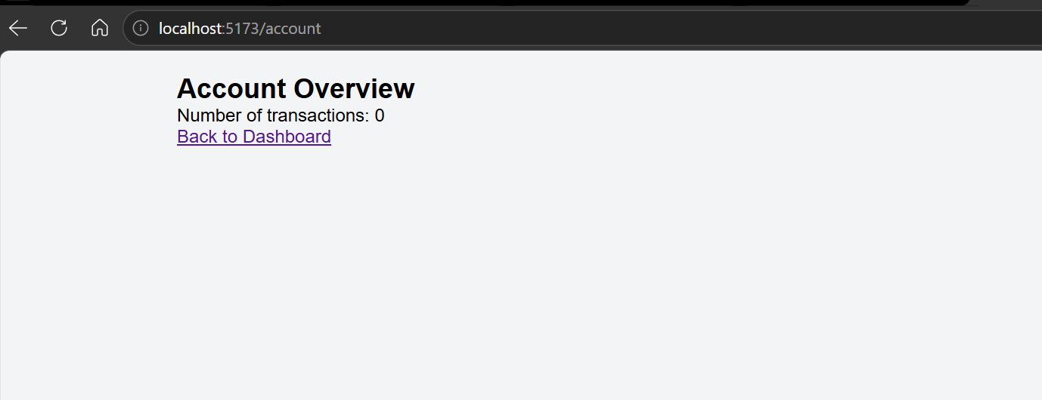

Task 10:

Redux:
Task 11:
Why do we need to maintain the state throughout the app..?
State is the data that an application needs to remember and use while the user interacts with it.
In React, we maintain state so that when data changes, the UI automatically updates.
const [balance, setBalance] = useState(5000);

Reason | Explanation
1. Store changing data | Stores values such as balance, username, transactions, login status, etc.
2. Update UI automatically | When state changes, React re-renders the component.
3. Share data | State can be shared between components using props, Context API, Redux, etc.
4. Maintain user information | Keeps track of things like logged-in user, selected account, cart items, etc.
5. Handle user interactions | Useful for buttons, forms, dropdowns, counters, and other interactions.

function AccountDetails() {

const [balance, setBalance] = useState(5000);

const deposit = () => {
setBalance(balance + 1000);
};

return (
<div>
<h2>Balance: ₹{balance}</h2>

<button onClick={deposit}>
Deposit ₹1000
</button>
</div>
);
}

Task 12:
What is useSelector used for ?
useSelector is a React-Redux hook used to read/access data from the Redux store inside a React component.

import { useSelector } from "react-redux";

function AccountDetails() {

const balance = useSelector(
(state) => state.user.balance
);

return <h2>Balance: ₹{balance}</h2>;
}

